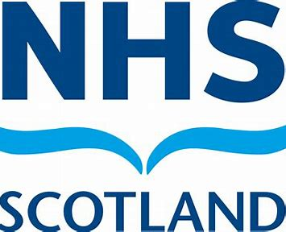
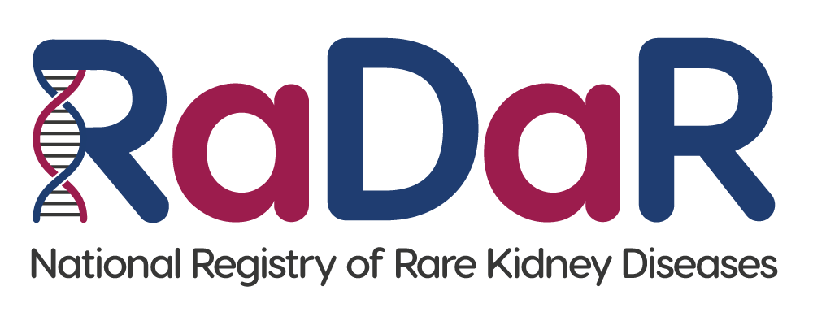
PARTICIPANT INFORMATION SHEET
Nearest Relative/Guardian or Welfare Attorney

This patient currently lacks the capacity to make an informed decision about whether they can take part in a research study. We are therefore asking you as their nearest relative, guardian or welfare attorney if you will give consent on their behalf to join this study. This is permissible under the Adults with Incapacity (Scotland) Act 2000. We would ask that you put your own views about the research aside and to consider instead, any known past and present wishes and feelings of the person you are consenting for.

Before you decide it is important for you to understand why the research is being done and what it will involve. Please take time to read the following information carefully and discuss it with others if you wish. Please ask if there is anything that is not clear or if you would like more information.

1. Introduction
For every 100,000 people in the UK, around 70 are living with a rare kidney condition. These people account for more than a quarter of patients receiving kidney replacement therapy, that is, treatment to help replace the usual blood-filtering function of the kidneys because the kidneys are not working well. Rare conditions can be hard to understand and diagnose and many still have no effective treatment. Doctors might go years without seeing a single case and this means experts can be hard to find.

The National Registry of Rare Kidney Diseases (RaDaR) collects and stores information from patients with rare kidney conditions in one central place. We sometimes ask other people to join too because information from healthy people or those with non-rare kidney conditions can also be essential to help us answer certain questions.

RaDaR currently holds information on more than 34,000 people and is the largest collection of rare kidney disease data in the world. Having all this data together enables healthcare professionals and researchers to:

A. Better understand the causes of disease
B. Improve current treatments and find new ones
C. Study side-effects and outcomes
D. Learn how patients are affected in their everyday life

If you think the person you are consenting for would be interested in being part of RaDaR, more information is given below. Please read this carefully before you make any decision. Take time to ask questions and talk things through with family and friends if you want to.

2. What will happen if I consent for this person to take part?
If you agree for the person you are consenting for to take part, information about their treatment and any medications they are on will be entered into the RaDaR database by a member of their hospital’s clinical/research team, or electronically sent to RaDaR.

You will be contacted from time to time, either by post, email or text to keep you updated, let you know about research opportunities (including trials for new treatments), events you might want the person you are consenting for to participate in or with a voluntary survey asking you to tell us about their personal experience of something we are studying. Only members of the RaDaR Team and the Clinical Leads appointed to manage rare disease groups within RaDaR will be able to contact you.
3. What are the possible benefits of taking part?
It is possible that the person you are consenting for may not receive any direct benefit from participating in RaDaR, however, the research conducted using their information is likely to help people with rare kidney disease in the future. You will be kept informed of opportunities them to participate in research studies and clinical trials. Some of these will have the potential to benefit them directly.

4. What are the possible risks of taking part?
Participating in RaDaR will not cause the person you are consenting for any disadvantages. You may feel there is a risk of them being identified by researchers using their data in their studies, but to avoid this, their record will be given a unique number, so that when researchers look at their information, they will not have any of their personal details.

5. What information will you collect and how?
By using their NHS number, date of birth and initials we can find the person you are consenting for in other data collections and bring their information into RaDaR. These include:

- Their GP record.

- Their kidney unit and hospital record.

- The UK Renal Registry. This registry collects information from patients with chronic kidney disease and those who are on kidney replacement treatments such as dialysis or a kidney transplant. This helps monitor standards of care across the country and will include data items such as dialysis sessions and transplant results.

- NHS Hospital Episode Statistics (England only): This includes information about appointments and stays in hospital, including when, why and for how long. This allows researchers to track the health of RaDaR patients over time.

- Civil Registration Services data (England only): This includes information on patients who have died, including the date and cause of death.

For patients not in England, hospital episodes and death information come from: Patient Episode Database for Wales, Information Services Division Scotland, and Health and Social care services Northern Ireland.

- UK Health Security Agency. This agency provides cancer and infection information.

  - Digital Personal Health Records. For example, Patients Know Best. They might not have one of these records.

- Any other ethically approved research studies, registries or bio-banking schemes that they have participated in or may do so in the future.

By consenting for this person to join RaDaR you will be giving researchers permission to use their past, present and future clinical data for ethically approved research into rare kidney diseases and related conditions. It is important for you to understand that consenting for this person to take part in RaDaR is entirely voluntary. If you do not consent, it will not affect their treatment or medical care in any way, and you do not have to give a reason.

6. Will their information be kept safe?
Information collected for the person you are consenting for will be held securely by the UK Kidney Association (UKKA). The UKKA’s offices are in Bristol, UK.

The UKKA, which owns and operates both RaDaR and the UK Renal Registry, collects, stores and uses data in line with the requirements of the Data Protection Act (2018) (also known as the UK GDPR), as well other laws which regulate the responsible use of data and to protect their confidentiality.

Every year, the UKKA is accredited by the NHS to make sure that it has suitable systems and protections in place to keep data secure and safe. Full details of how the UKKA processes patient data can be found in the Patient Privacy Notice. You can ask this person’s clinician for a copy or find a digital version on the UKKA website: https://ukkidney.org/patients/your-data

7. Will their kidney doctor know about this?
Yes. Their doctor and other members of their clinical care team know about RaDaR and can discuss it with you if you wish.

8. Can I have time to think about this?
Yes, you can take as much time as you need.

9. What happens if I change my mind?
You can withdraw consent at any time, without giving a reason. You can either write to RaDaR directly or ask their kidney doctor to make this change. We will stop collecting new information about the person you are consenting for, and you will not be contacted again. Any data collected up to the point of withdrawal will be retained and used. Leaving RaDaR will not affect their treatment or medical care in any way.

10. Who can I speak to if I have any questions?
The kidney doctor or nurse caring for the person you are consenting for can help with many of your queries. Alternatively, you can contact the RaDaR Operations Manager by using the email address below.

11. Who is responsible for RaDaR?
RaDaR was set up jointly by the Renal Association (now known as the UK Kidney Association) and the British Association for Paediatric Nephrology. RaDaR is overseen by a Rare Disease Committee and has been approved by the Southwest - Central Bristol Research Ethics Committee (reference 19/SW/0173).

12. What if I want to complain?
If you have any concerns about RaDaR please contact us directly or raise them with your kidney doctor.

RaDaR Operations Manager, UK Kidney Association, 1st floor Brandon House, Building 20A1, Southmead Road, Bristol, BS34 7RR. Email address: radar@ukkidney.org

If you would like to speak with someone independent from the study, please contact Dr James Medcalf. Email: James.Medcalf@ukkidney.org. Telephone: 0117 414 8150.

Thank you for taking the time to read this information sheet

